A Visit to Lake Geneva
Wednesday, July 22nd Departing Cedarburg at 9:00 Returning at 5:30 Cost: $151 Includes Coach Bus, Luncheon Cruise and Museum Admission, Water and Snack for the ride home
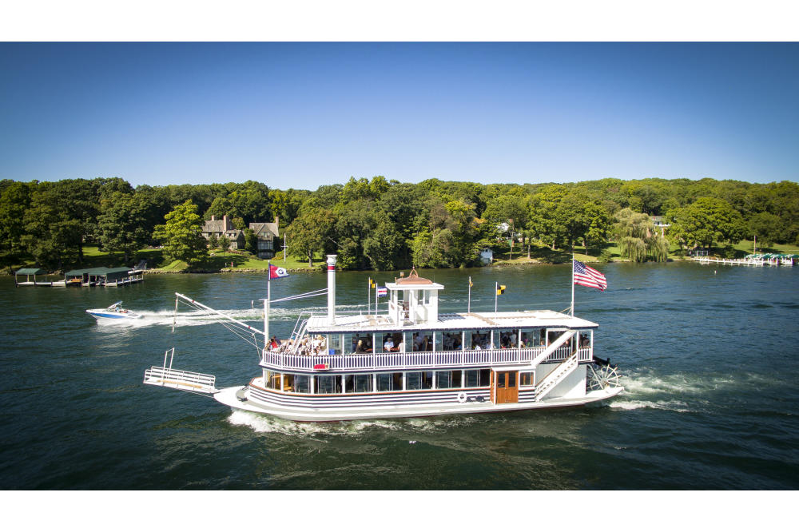
Back by popular demand!! Enjoy a delicious sit-down lunch aboard the climate-controlled Grand Belle while listening to a narrated tour highlighting the history of the prominent families who called this lake home during the summer months. We’ll arrive back at the dock with time to stroll (and shop a little!) through downtown on your way to the Geneva Lake Museum for a welcome and introduction before you explore the exhibits on your own.

