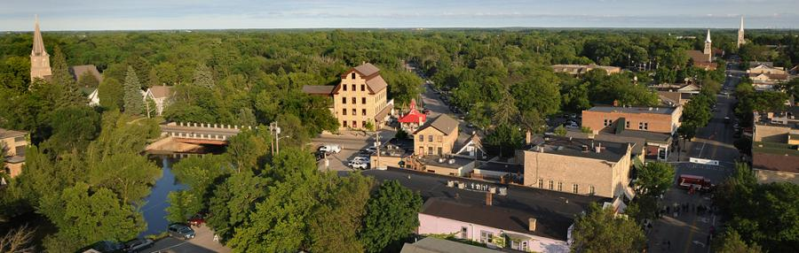
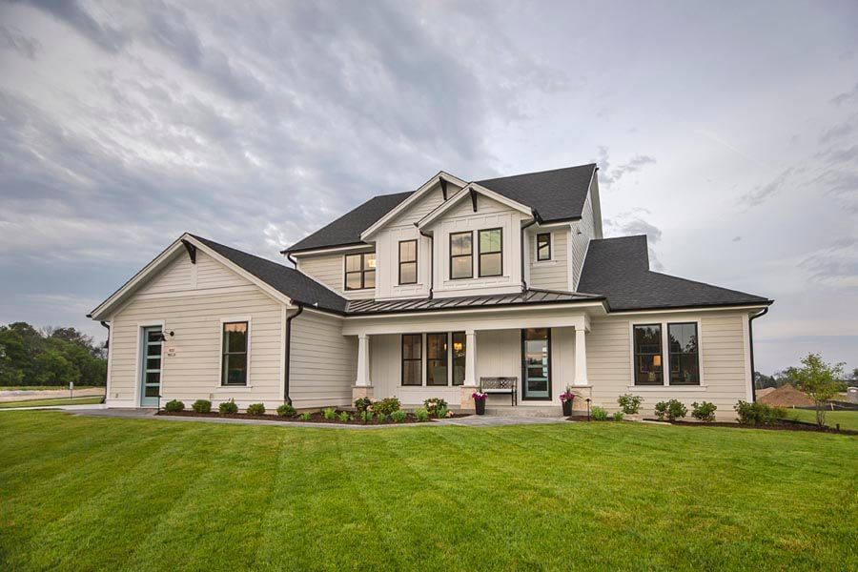
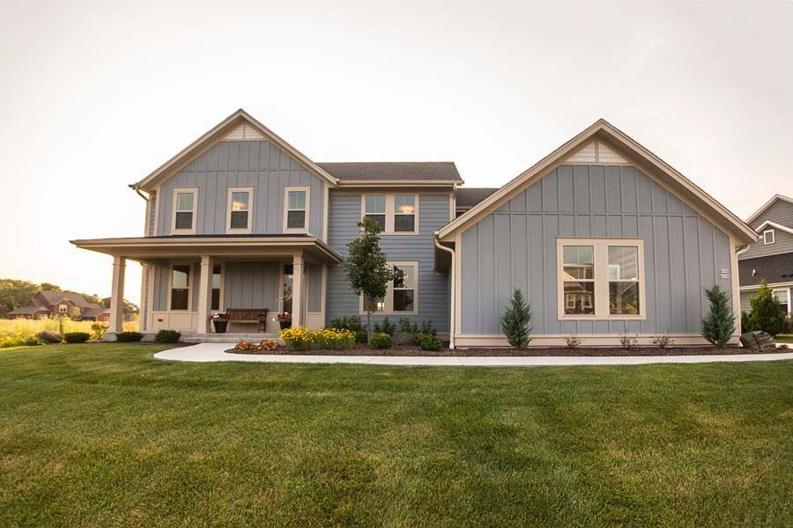
2021
HOUSING AFFORDABILITY REPORT

CITY OF CEDARBURG

HOUSING AFFORDABILITY REPORT

State Stats Section 66.10013 requires a municipality with a population of 10,000 or more to prepare a report of the municipality’s implementation of the housing element of the municipality’s comprehensive plan. This report shall contain the following:

- The number of subdivision plats, certified survey maps, condominium plats, and building permit applications approved in the prior year.

- The total number of new residential dwelling units proposed in all subdivision plats, certified survey maps, condominium plats, and building permit applications that were approved by the municipality in the prior year.

- A list and map of undeveloped parcels in the municipality that are zoned for residential development.

- A list of all undeveloped parcels in the municipality that are suitable for, but not zoned for, residential development, including vacant sites and sites that have potential for redevelopment, and a description of the zoning requirements and availability of public facilities and services for each property.

- An analysis of the municipality’s residential development regulations, such as land use controls, site improvement requirements, fees and land dedication requirements, and permit procedures. The analysis shall calculate the financial impact that each regulation has on the cost of each new subdivision. The analysis shall identify ways in which the municipality can modify its construction and development regulations, lots sizes, approval processes, and related fees to do each of the following:

  - Meet existing and forecasted housing demand.

  - Reduce the time and cost necessary to approve and develop a new residential subdivision in the municipality by 20 percent.

  - A municipality shall post the report under sub (2) on the municipality’s internet site on a web page dedicated solely to the report and titled “Housing Affordability Analysis”.

Accordingly, the following is the City of Cedarburg’s Housing Affordability Report for the development and zoning activity for the year 2021.

Subdivision, Condominium Plats, Certified Survey Maps and Building Permits Approved in 2021
- One final plat for the first phase of a subdivision consisting of eight townhome buildings and fifty-two single family homes, for a total of 68 units.
- One final plat for a subdivision consisting of seven single family homes.
- Two hundred seventy-eight residential building permits total; twenty-eight of these for new dwelling units.

Undeveloped Parcels that are Zoned Residential
A list of thirteen parcels can be found on the following table. See Exhibit A for the corresponding map.

Undeveloped Parcels that are Zoned Residential
# | Tax Key No | Owner(s) | Acres | Zoning
1 | 13-040-0140.000 | Graham Benz | 18.38 | Rs-3 Single-Family
2 | 13-027-10-011.00 | Barb Dochow Trust | 8.05 | Rs-4 Single-Family
3 | 13-023-06-007.00 | Clyde Wirth | 17.1 | Rs-1(temp) Low-Density Single-Family
4 | 13-015-13-002.00 | Airport View LLC | 19.8 | Rs-1(temp) Low-Density Single-Family
5 | 13-015-16-002.00 | Airport View LLC | 36.94 | Rs-1(temp) Low-Density Single-Family
6 | 13-027-11-019.00 | Linmar Property Group | 1 | Rs-3 Single-Family
7 | 13-022-13-005.00 | Jack and Jerod Henning | 4.4 | Rs-3 Single-Family
8 | 13-050-22-03.003 | Paula Motte | 1.94 | Rs-5 Single-Family
9 | 13-069-01-03-000 | John and Karen Friess | 0.327 | Rs-5 Single-Family
10 | 13-050-17-05-000 | Hoffmann Family Trust | 1.7 | Rs-5 Single-Family
11 | 13-051-01-05-00 | Oliver Fiontar LLC | 4.02 | Rs-6 Single-Family/Two-Family
12 | 13-023-09-009.00 | Joseph and Nancy Messinger | 16.8 | Rs-2 Single-Family
13 | 13-023-10-05.000 | Dippmann Trust | 15.9 | Rs-1(temp) Low-Density Single-Family

Undeveloped Parcels Suitable but not Zoned for Residential
A list of six parcels can be found on the following table. See Exhibit A for the corresponding map.

Undeveloped Parcels Suitable but not Zoned for Residential
# | Tax Key No | Owner | Acres | Existing/Future Zoning
1 | 13-022-13-003.00 | Michael Halloran | 10 | A-1(temp)/Rs-3
 | Description: This property is located behind the home at W60 N1085 Sheboygan Road and north of Holly Road extended. The Comprehensive Land Use Plan classifies this site as Medium Density Residential at 3.6 units/acre to 5.2 units/acre and the site is currently zoned A-1 Agricultural District (Temporary). To maintain consistency with adjacent zoning, it is anticipated that future zoning will be the Rs-3 Single-Family District, 12,000 square foot minimum lot sizes. Public sewer and water are available to this site.
2 | 13-050-10-16.000 | Madison Avenue Properties LLC | 3 | M-1
 | Description: This property is located between Madison Avenue and St. John Avenue directly south of Cleveland Street. The Comprehensive Land Use Plan classifies this site as High-Medium Density Residential ranging from 5.2 units/acre to 10.8 units/acre. Public sewer and water facilities are available.
3 | 13-050-10-15.007 | Brunswick Corporation | 1.9 | I-1
 | Description: This property is located directly south of the Madison Avenue Properties LLC site identified above. The Comprehensive Land Use Plan currently classifies this site as Government and Institutional; however, that classification was based on a failed Library project and therefore the classification could be changed to High-Medium density Residential ranging from 5.2 units/acre to 10.8 units/acre. Public sewer and water facilities are available.
4 | 13-050-19-01.001 | Jackson Western LLC | 12.9 | M-2/Rs-5
 | Description: This property is located along the south side of Western Rd and directly east of the Interurban Trail. The Comprehensive Land Use Plan classifies this site as Medium Density Residential ranging from 3.6 units/acre to 5.2 units/acre. The site is currently zoned M-2 General Manufacturing. Public sewer and water facilities are available.
5 | 13-050-21-09-000 | Oliver Fionar LLC | 2.4 | MUID
 | Description: This property is located southeast of the Johnson Avenue and Hamilton Road intersection. The Comprehensive Land Use Plan classifies this site as Mixed-Use Office and/or High-Density Residential ranging from 5.2 units/acre to 10.8 units/acre. Public sewer and water facilities are available to the site.
6 | 13-050-21-08-000 | Oliver Fionar LLC | 2 | MUID
 | Description: This property is located directly south of the other Oliver Fionar LLC site identified above. The Comprehensive Land Use Plan classifies this site as Mixed-Use Office and/or High-Density Residential ranging from 5.2 units/acre to 10.8 units/acre. Public sewer and water facilities are available to the site.

Residential Development Regulations Analysis
All new City development must go through an approval process that includes staff review for the technical requirements and then action by the Plan Commission or the Common Council or both bodies. City development is technically regulated through the following:

- Comprehensive Land Use Plan 2025
- Architectural review principles, standards and procedures (Zoning Code)
- The Official Map
- Historic Preservation (Zoning and Building Codes)
- Subdivision Ordinance
- Sign Code
- Zoning Ordinance
- Parking Regulations (Zoning Code)
- Erosion Control and Stormwater Management Ordinance

Comprehensive Land Use Plan - 2025
The intent of the Comprehensive Land Use Plan – 2025 serves as a guide for the future development of the City. It addresses the general location and intensity of residential development coupled with the concentrations of commercial, industrial, and institutional uses. In consideration of the age of this plan and the fact that the 2021 Census has now been completed, and therefore, this plan will be revisited and updated with new census data and figures. At that time, it is recommended the Plan Commission in agreement with the Common Council provide staff direction on such issues as density, lot size, and type of residential development, etc.

The Architectural Review Principles, Standards and Procedures
This section of the Zoning Code is intended to provide criteria to ensure new structures are compatible with the character of the City in general and the surrounding area. The relative proportion of a building to its neighboring existing building, to pedestrians or observers or to other existing buildings shall be maintained or enhanced, rooflines and shapes shall be consistent with neighboring buildings and material selection shall be based on the prevailing materials already being used in the area.

The Official Map
This map is adopted by the Common Council by ordinance and shows the location and width of proposed streets, public facilities and public areas and drainage right-of-way.

Historic Preservation
The public policy of the City is to protect, enhance and perpetuate structures and Districts of special historical interest or value. The Historic Preservation Overlay District (HPD) provides protection, enhancement and perpetuation of such improvements and districts by setting forth the rules under which changes can take place and defining the approval process to be followed. More specifically, the HPD prohibits the issuance of permits to develop, construct, reconstruct, enlarge, or alter property in the Historic Preservation Overlay District. Furthermore, no land shall be removed from the district until the Landmarks Commission has reviewed the application or petition and has recommended approval, approval with conditions or denial to the Plan Commission.

Subdivision Ordinance
The purpose of the Subdivision Ordinance is to regulate and control the division of lands or the creation of condominiums to divide land ownership within the corporate limits of the City and within its extraterritorial plat approval jurisdiction. These regulations are designed to lesson congestion on the highways and streets; foster the orderly layout and use of land; ensure safety from fire panic and other dangers; provide adequate light and air; discourage over-crowding of land; facilitate adequate provisions for housing, transportation, public water and sewerage, school, parks, playgrounds and other public necessities; ensure safety from flooding, water pollution, diseases, and other potential hazards.

Sign Code
The Sign Code is to provide the legal framework and minimum standards to safeguard life, property, public welfare, and aesthetics by regulating and controlling the design, number, size, quality of materials, construction, location, electrification, installation, and maintenance of all signs in the City. Due to the unique qualities of the City, a high degree of control over the aesthetic nature of signs is deemed to be important and therefore either the City Building Inspector, or if the sign is located in the Historic Preservation Overlay District the Landmarks Commission, is responsible for assuring that only aesthetically pleasing and functionally purposeful signs are displayed in the City.

Zoning Code
The intent of the Zoning Ordinance is to regulate and restrict the use of all structures, lands and waters with a view to conserving the value of buildings and encouraging the most appropriate use of land. Such regulations shall be made in accordance with the Comprehensive Land Use Plan and shall be designed to regulate lot coverage, size and location; population density and distribution; parking, loading and access and use of land, structures and water in order to:

- Prevent and eliminate overcrowding of land and undue concentration of population.
- Provide adequate sunlight and air.
- Facilitate the adequate provision of transportation, water, sewerage, drainage, schools, parks and other public services.
- Lessen congestion on the streets and promote safe and efficient use of streets and highways.
- Secure safety from fire panic, flooding, pollution, contamination and other hazards.
- Stabilize and protect property values.
- Preserve the beauty of the City of Cedarburg.
- Provide for a variety of suitable commercial and industrial sites.
- Prevent and control erosion, sedimentation and pollution of the surface and subsurface waters.
- Prevent flood damage to persons and property and minimize the costs of flood relief and flood control projects.
- Aid in the implementation of municipal, county watershed and regional comprehensive plans or components of such plans, adopted by the City of Cedarburg.
- Maintain safe and healthful water conditions.
- Provide for the administration and enforcement of this Chapter and provide penalties for the violation of the Zoning Code
Parking Regulations
In all districts and in connection with every use, the City code requires that at the time any use is introduced, or building is erected, enlarged, extended, or increased, off-street or on-street parking be provided or dedicated in accordance with the prescribed requirements set forth in section 13-1-82 of the Zoning Code.

Erosion Control and Stormwater Management
The Storm Water Management Ordinance was adopted under the authority granted by section 62.234 Wis. Stats. The purpose of this Ordinance is to establish long-term, post-construction runoff management requirements and criteria that will prevent and control water pollution, diminish the threats to public health, safety, welfare and the aquatic environment due to runoff of stormwater from development and redevelopment.

Typical Construction Improvements Required for Residential Development
A development agreement must be entered into and serves as the contract between the developer and the City. This agreement establishes the responsibilities of the developer regarding improvements and terms that have been mutually agreed upon. Typical responsibilities of the developer are as follows:

Lot Grading. The grading of all lots is required pursuant to the Improvement Plans and section 14-1-73(c) of the Subdivision Regulations approved by the City Engineer. Prior to the installation of all underground utilities, the developer shall certify to the City that the grading has been completed in compliance with the Improvement Plans and the Subdivision Regulations. In the event the actual grade is not in compliance, the developer shall pay all costs associated with relaying the underground electrical services.

Sanitary Sewerage Facilities. Developers are required to pay for and install all onsite sanitary sewerage facilities including all sewer mains and service laterals necessary to serve the subdivision as depicted in the Improvement Plans and included technical revisions as may be required by the City Engineer.

Water Supply Facilities. Developers are required to pay for and install all onsite storm water supply facilities including all water mains, service laterals and appurtenances necessary to serve the Subdivision as depicted in the Improvement Plans and including technical revisions as may be required by the City Engineer, pursuant to section 14-1-68 of the Subdivision Regulations.

Storm Water Drainage Facilities. Developers are required to pay for and install all onsite storm water drainage facilities pursuant to section 14-2 of the Subdivision Regulations necessary to serve the Subdivision as depicted in the Improvement Plans and including technical revisions as may be required by the City Engineer.

Private Utilities. Developers are required to file preliminary plans and shall agree to pay for and install underground gas mains and electric, cable television and telephone cables, pursuant to section 14-1-59 of the Subdivision Regulations. All private utilities are required to be completed prior to commencement of the binder course of pavement roadwork.

Survey Monuments. Developers are required to install survey monuments, pursuant to section 14-1-52(c)(4) of the Subdivision Regulations.

Record Drawings. Developers are required to prepare and record drawings for the above work, pursuant to section 14-1-52(e), provide full sized prints on 4 mil mylar as well an electronic version in AutoCAD.

Curb and Gutter. Developers are required to pay for and install all curb and gutter as shown on the Improvement Plans pursuant to section 14-1-54 of the Subdivision Regulations.

Sidewalks and Walking Paths. Developers are required to pay for and install five-foot-wide concrete sidewalks on both sides of all streets contained within the subdivision and along the subdivision frontage roads as shown on the Improvement Plans as approved by the City Engineer, pursuant to section 14-1-67 of the Subdivision Regulations. All sidewalks installed for public use shall be in the respective road right-of-way.

Intersection and Lane Improvements. Developers are required to pay for and install fully improved intersections with adjacent feeder roadways to the subdivision including concrete curbs and gutters, street lighting, storm sewers, and sidewalk.

Street Improvement. Developers are required to pay for street improvements as shown on the Improvement Plans and pursuant to section 14-1-53 of the Subdivision Regulations.

Streetlamps. Developers are required to contract with Cedarburg Light and Water to arrange for the installation of standard coach light streetlamps on a spacing plan approved by the City, pursuant to section 14-1-60 of the Subdivision Regulations.

Street Signs. Developers are required to pay for, and the City agrees to install street identification signs pursuant to section 14-1-61 of the Subdivision Regulations and any traffic control signs as required by the City Engineer.

Landscaping other than Street Trees. Developers are required to pay for and install landscape features as shown in the Improvement Plans.

Street Trees. Developers are required to pay for street trees as shown on the Improvement Plans and pursuant to section 14-1-62 of the City Subdivision Regulations. The City Forrester will select the tree species and contract out the tree planting as part of the annual street tree program. At the direction of the City Forrester, the trees will be planted each year as new homes are completed.

Erosion Control. Developers are required to pay for, install and maintain erosion control using best management practices and pursuant to section 14-1-63, Chapter 14-2, and Chapter 15-2. Developers must comply with all applicable DNR permits, the City’s Erosion Control Permit, and the Storm Water Management Permit.

Impact and Connection fees. Prior to issuance of any building permit and payable at the time of building permit issuance, the following impact and connection fees will be due for each lot (2021 prices, per lot):
Single Family Multi-Family
- WWTF Reserve Capacity Fee $ 702.49 $ 466.60
- Library Building Fee $ 911.63 $ 605.49
- Police Station Fee $1,042.90 $ 692.68
- Park Facilities Fee $1,245.00 $ 826.90
- Water Supply Facilities Fee $2,049.98 $1,537.50
- Sanitary Sewer Connection Fee $1,508.61 $1,001.97
- Total Fee Per Unit $7,460.61 $5,131.14

Since the total cost of improvements will vary for each development, one will need to calculate the value of the following line-item list on a case-by-case basis to determine the financial impact that each required improvement has on new subdivisions:

- Rough Grading
- Sanitary Sewer and Laterals
- Water Main and Laterals
- Storm Sewer and Laterals
- Fine Grading and Street
- Concrete Curb and Gutter
- Road Base
- Asphalt Pavement Binder Course
- Concrete Sidewalks
- Fine Grading, Topsoil, Seeding and Mulching
- Asphalt Pavement Surface Course
- Street Lighting
- Landscaping
- Street Signs
- Lot Piping
- Legal Fees
- Inspection Fees
- Administration Fees

Modification of Approval Process and Fees
In order to modify the approval processes and related fees to meeting existing and forecasted housing demands and to reduce the costs and timing to get through the approval process by 20%, the City will need to re-evaluate and likely amend the impact fee Ordinance, the Zoning Code and the Comprehensive Land Use Plan. The Comprehensive Land Use Plan will be revisited and updated in 2022 with the 2021 Census information. This Plan update should be followed by the recodification of the City’s Zoning Code to ensure that the Zoning Ordinance and the Comprehensive plans are consistent with each other.

Impact Fee Ordinance:
In 2001, the City hired certified public accountants, Virchow, Krause & Company, LLP, to conduct a public needs assessment and impact fee development for the Library, Police and Parks improvement. The intent of this study was to develop impact fees based on library, police and park facilities that have been completed, or were in the planning process or construction phase in the City. The purpose of this study was to serve as the public facilities needs assessment in imposing impact fees for the City. In 2002, the City hired McMahon Associates, Inc. to conduct a study and prepare the Sanitary Sewer Connection Fee Calculation and this calculation was based on the Sanitary Sewer System Planning Report, dated March 15, 2001 and prepared by McMahon Associates, Inc. These studies were the basis for the adoption of Ordinance No. 2001-54, Establishing Impact Fees Upon Land Development. The City’s impact and sewer connection fees are updated on an annual basis through the adoption of separate ordinances. To reduce the impact and sewer connection fees by 20%, the City will need to re-evaluate this study annually to achieve that goal.

Zoning Code:
The City is currently in the process of re-codifying the Zoning Code and will likely schedule it for Plan Commission review and Common Council public hearing in 2022. Through this recodification process, the City will need to analyze the improvements required for development in the City and the approval process requirements and the density restrictions to determine what adjustments are necessary to reduce the costs and processes by 20%.
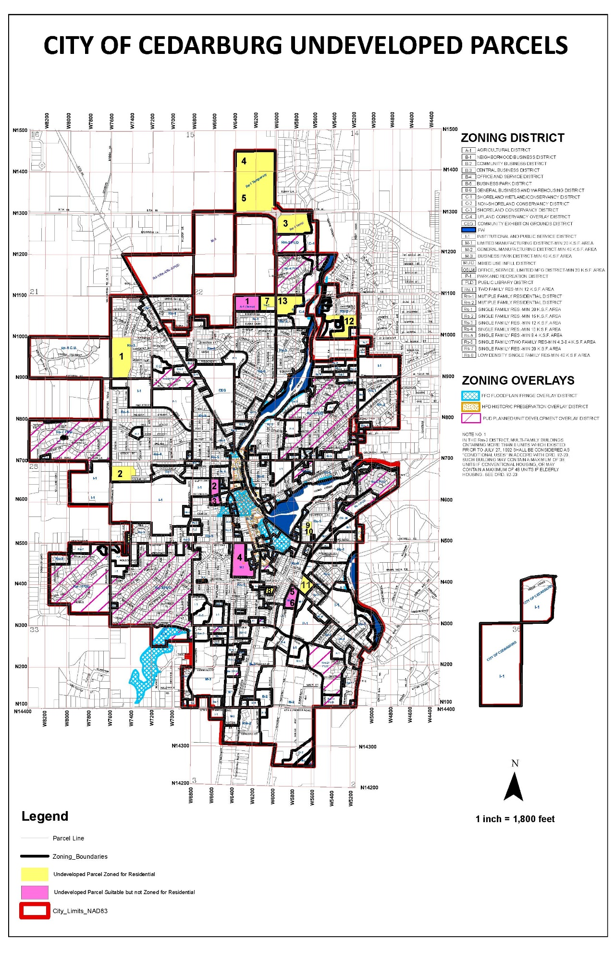
Exhibit A

